Exp:7- Determination and plotting of Capacitance of isolated sphere and co-axial cable with different
dimensions and dielectric constant.
Aim:
To write program for capacitance of isolated sphere and co-axial cable with different radius and dielectric
constant using MATLAB.
Software required:
•MATLAB (R2018 or later)
Test case (i) Determination of capacitance of isolated sphere for given radius
Program:
clc;
clear;
epsilon0 = 8.854e-12;
R = input('Enter radius of sphere (m):');
C = 4*pi*epsilon0*R;
disp('Capacitance of isolated sphere is');
disp(C);
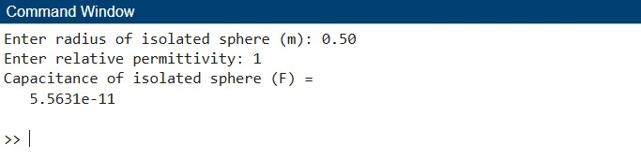
Test case (ii) Determination and plotting of capacitance of isolated sphere with varying
radius
clc;
epsilon0 = 8.854e-12;
R = linspace(0.1,2,100);
C = 4*pi*epsilon0*R;
plot(R,C,'LineWidth',2);
xlabel('Radius (m)');
ylabel('Capacitance (F)');
title('Capacitance of isolated sph
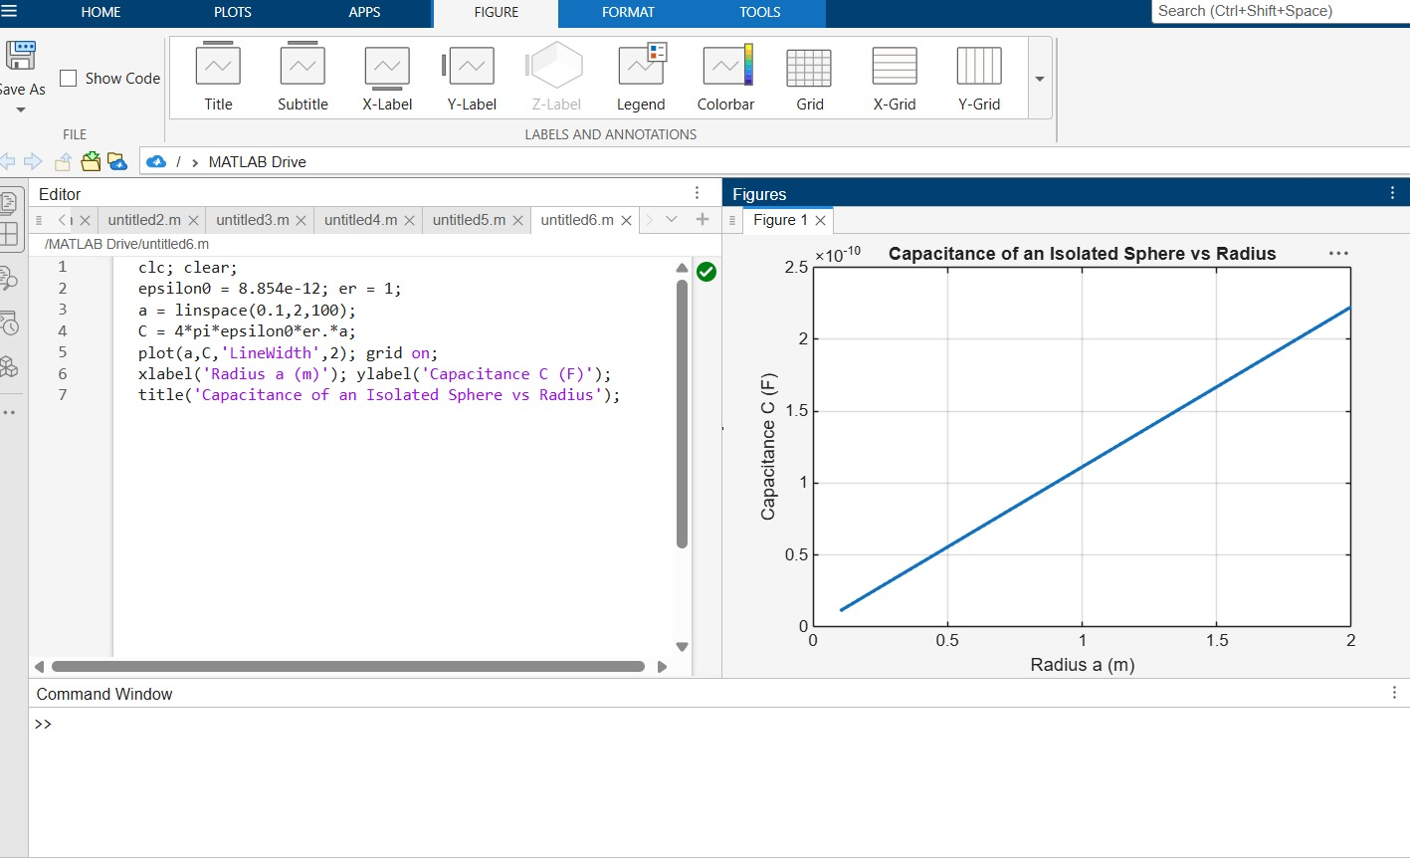Test case (iii) Determination of capacitance per unit length of co-axial
cable clc;
epsilon0 = 8.854e-12;
a = input('Enter inner radius (m):');
b = input('Enter outer radius (m):');
er = input('Enter dielectric constant:');
epsilon = epsilon0*er;
C = (2*pi*epsilon)/log(b/a);
disp('Capacitance per unit length is');
disp(C);
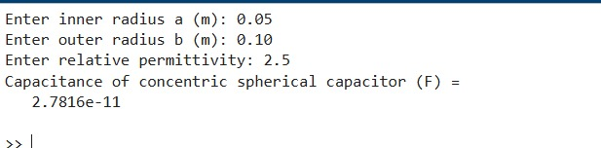Test case (iv) Determination and plotting of capacitance variation with dielectric constant
in co-axial cable
clc;
epsilon0 = 8.854e-12;
a = 0.01;
b = 0.05;
er = linspace(1,5,100);
epsilon = epsilon0*er;
C = (2*pi*epsilon)./log(b/a);
plot(er,C,'LineWidth',2);
xlabel('Dielectric constant');
ylabel('Capacitance (F/m)');
title('Capacitance vs dielectric constant (coaxial cable)');
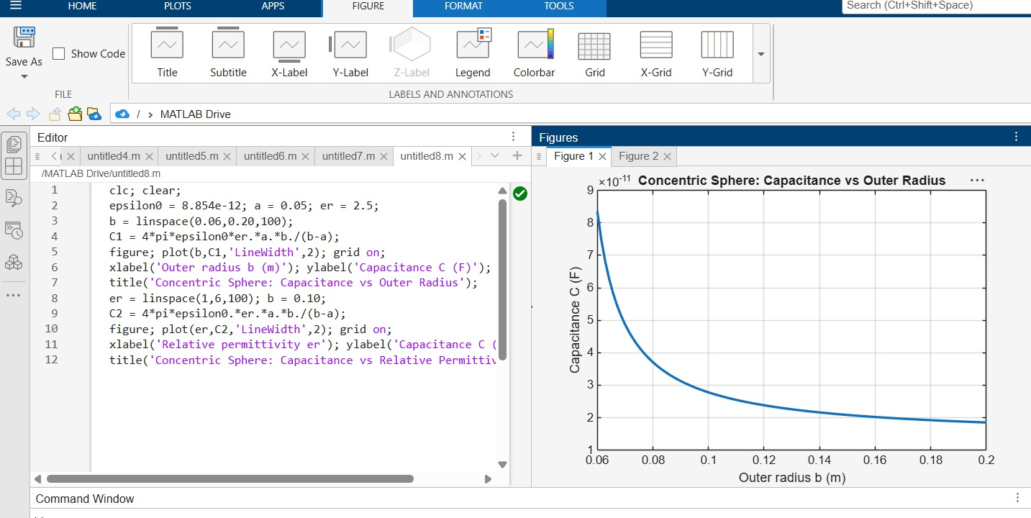
RESULT:
Thus the program was verified for capacitance of isolated sphere and co-axial cable using MATLAB was successfully

